Ideation Phase

Brainstorm & Idea Prioritization Template
Project Title | DarshanEase: A Smart Temple Darshan Booking System Using MERN Stack
Team ID | ALITS-CSD-2026-DarshanEase
Team Members | Salapala Tharun Kumar Reddy (Team Leader); A. Goutham; M. Siva Prasad; M. Akhila; K. Hemalatha
College | Anantha Lakshmi Institute of Technology and Sciences (ALITS)
Academic Year | 2026

Step 1: Team gathering and problem statement selection
The team reviewed all four problem statements from the Define Problem Statements phase and selected PS-1 and PS-2 as the primary focus, since fragmented booking and travel planning affect the largest number of devotees.
Step 2: Brainstormed ideas
Category | Ideas generated
Booking | Online darshan slot booking; QR-code e-tickets; waitlist for full slots; multi-temple search
Travel | Integrated bus/train/flight journey planner; nearby accommodation suggestions; route maps
User experience | Mobile-responsive UI; multi-language support; booking history dashboard; saved favourite temples
Admin | Admin dashboard for slot management; booking analytics; crowd-level indicators
Communication | Email/SMS notifications; booking reminders; darshan-day alerts
Step 3: Idea prioritization
Ideas were prioritized using an impact-versus-effort assessment. High-impact, feasible-effort ideas were selected for the MVP scope of DarshanEase.
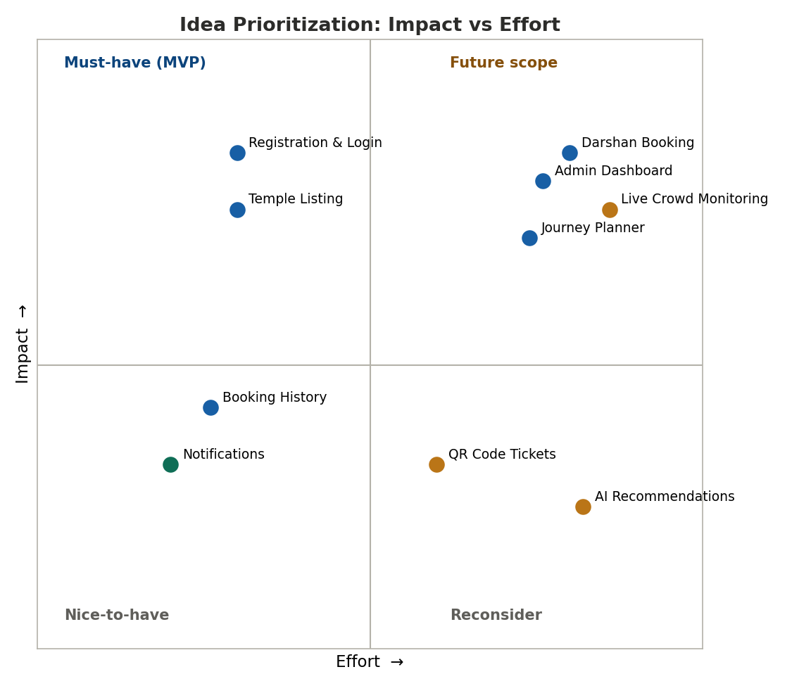
Figure: Impact vs effort prioritization matrix
Idea | Impact | Effort | Priority
User registration & login | High | Low | Must-have (MVP)
Temple listing & details | High | Low | Must-have (MVP)
Darshan booking & confirmation | High | Medium | Must-have (MVP)
Booking history | Medium | Low | Must-have (MVP)
Journey planner (bus/train/flight) | High | Medium | Must-have (MVP)
Notifications | Medium | Low | Should-have
Admin dashboard | High | Medium | Must-have (MVP)
QR code tickets | Medium | Medium | Future scope
AI-based recommendations | Medium | High | Future scope
Live crowd monitoring | High | High | Future scope

